LAB Logbook
GITHUB Link - https://github.com/vishnu7411/Cyber-Securiy-and-AI
(All 10 labs)

Lab 1
DataFrame – The core Pandas class that represents tabular data in rows and columns, much like a spreadsheet or SQL table.
Series – A one-dimensional labeled array that can hold any data type, often used to represent a single column or row from a DataFrame.
Index – An immutable array used to label the axes of Series or DataFrames, enabling fast lookups and alignment.
Categorical – A class that represents a variable with a fixed number of possible values (categories), useful for memory-efficient encoding of repeated labels.
Timestamp – A class for representing individual points in time, offering powerful date-time functionality for time series analysis.
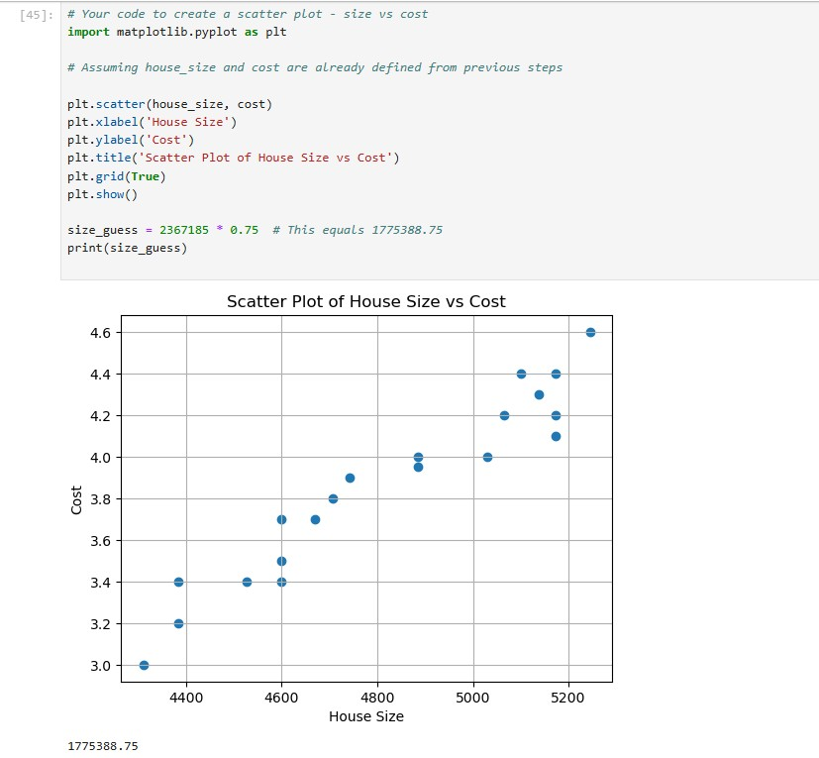
Lab 2

Lab 3
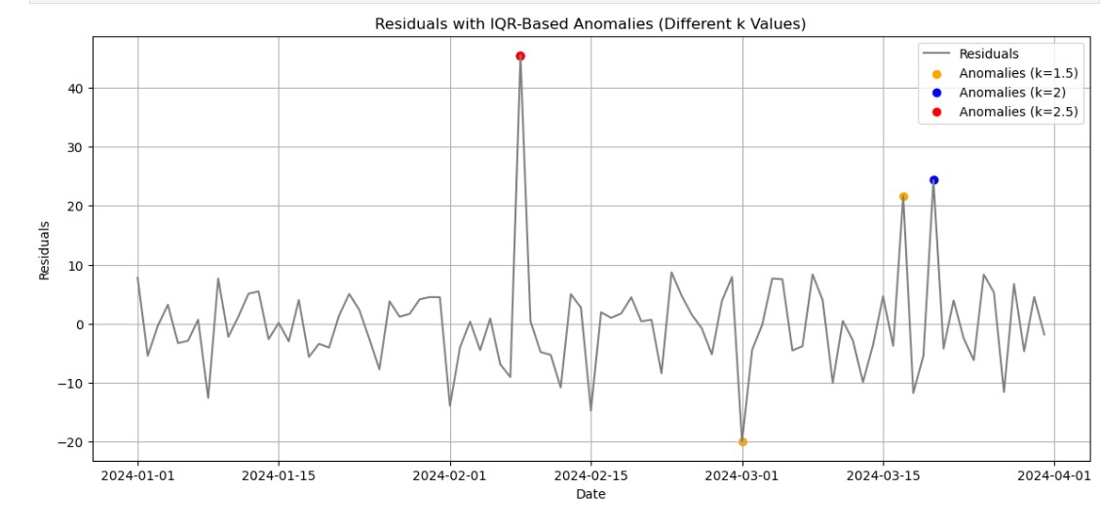

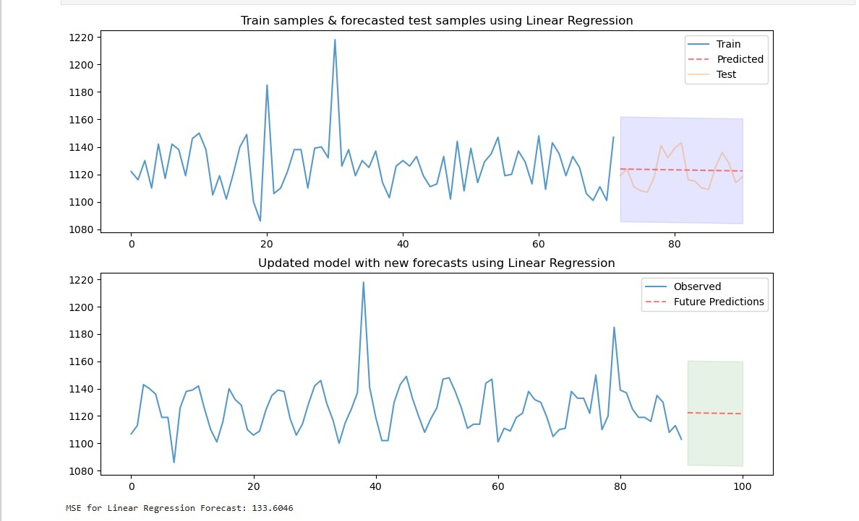

Lab 4
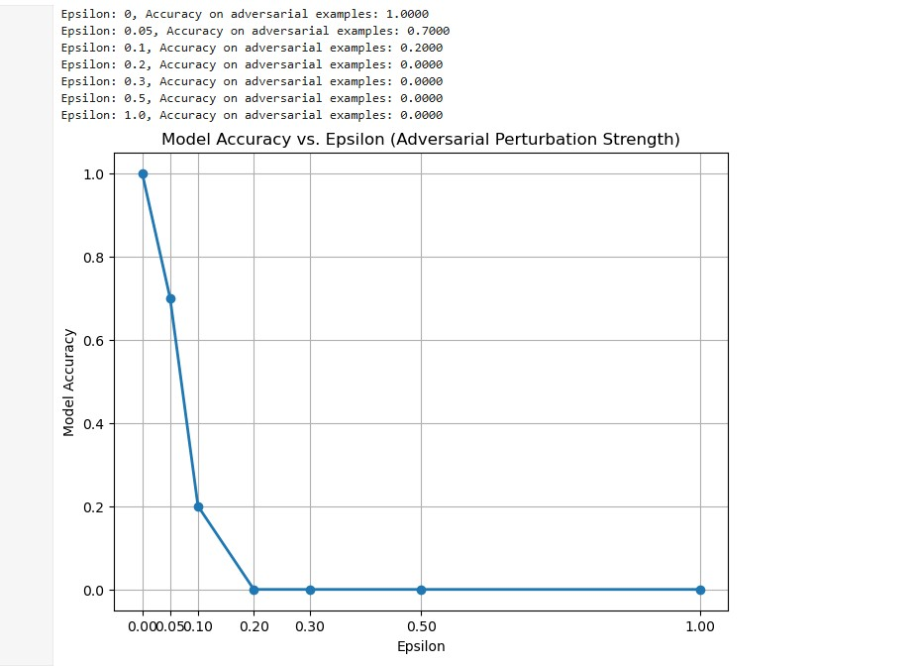

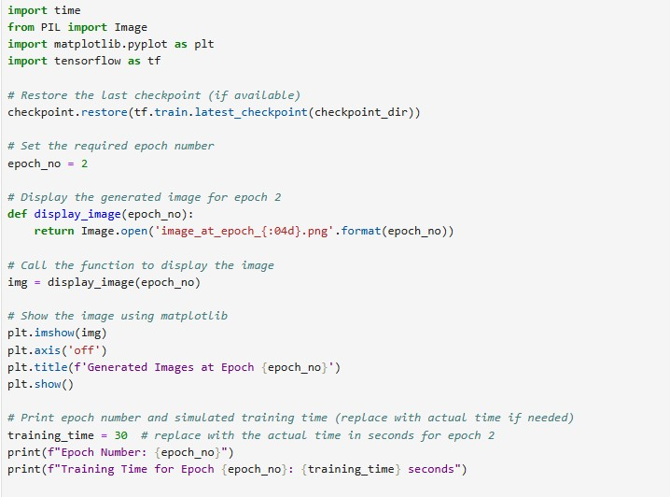
Lab 5

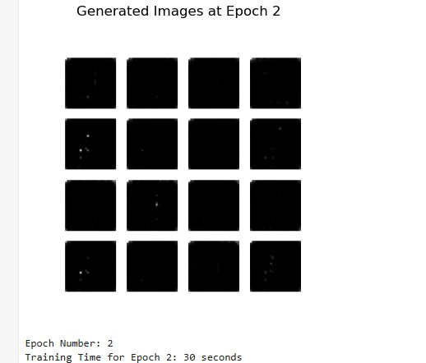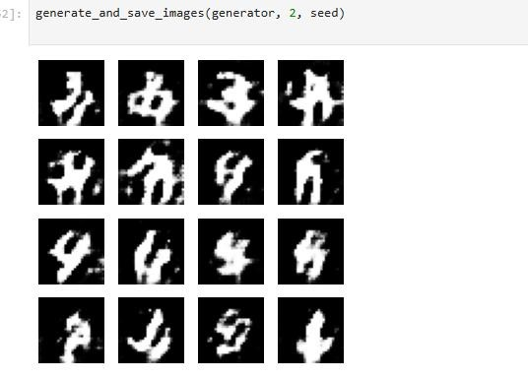

Lab 7

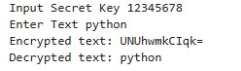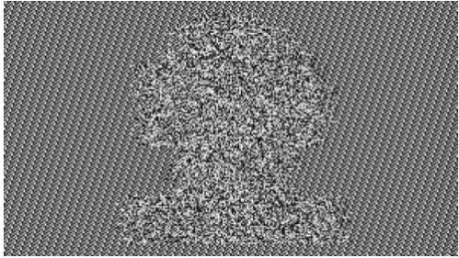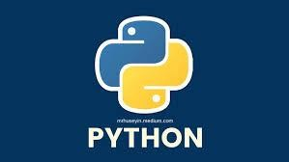

YES

Lab 8
Partner’s name - Keerthana
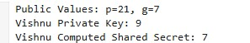
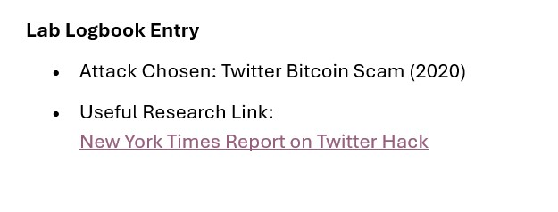
Lab 9

Lab 10
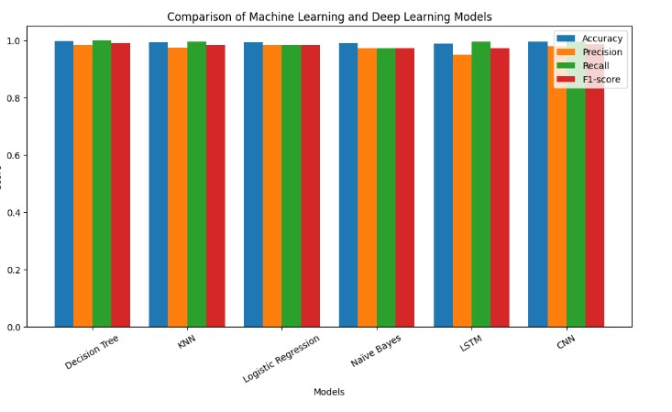

Lab 11
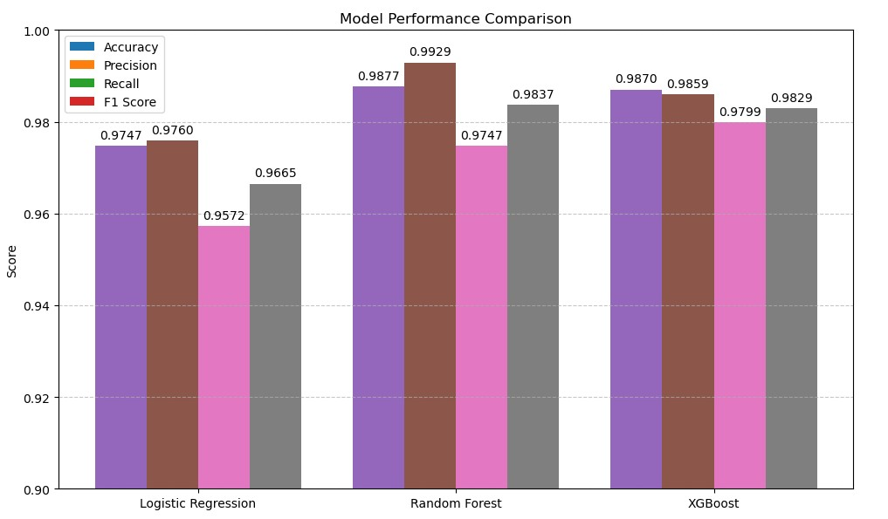
Lab 12
No Activity for Lab Logbook (Exam)

